MGDF celebrates International Guide Dog Day
The Malta Guide Dogs Foundation (MGDF) on 25 April 2014 celebrated International Guide Dog Day with a commemoration presided by Social Dialogue Minister Helena Dalli.
During the event, held in the conference hall of Borg Cardona & Co. Ltd in Ta’ Qali, the minister presented long service certificates to guide dog owners and their guide dogs who have been working together for more than a year.
Certificates of attendance were presented to all those who followed Orientation and Mobility training, with long-serving MGDF treasurer Francis Naudi receiving a certificate of recognition. Among those present was MEP candidate Arnold Cassola.
Ms Dalli paid tribute to the selfless work done by all those in the voluntary sector and in particular to the MGDF for helping people to live independently.
In his address, MGDF chairman Leone Sciberras recalled the rights of those who own a guide dog to enter everywhere with them – in public places, hotels, restaurants and on public transport – as part of their normal, everyday life.
“These are working dogs that are trained by experts and it is only after months of training and after they are matched in character and stature with their owners, who are given further training themselves, that they start working together as a team,” he said.
He referred to an event planned for the morning in Valletta, which unfortunately had to be cancelled due to expected high winds. This, he said, has been postponed to a later date when members of the foundation and guide dogs and their owners will meet people walking by and speak to them about their experience and the MGDF’s work locally among blind people.
– ENDS –
Captions:

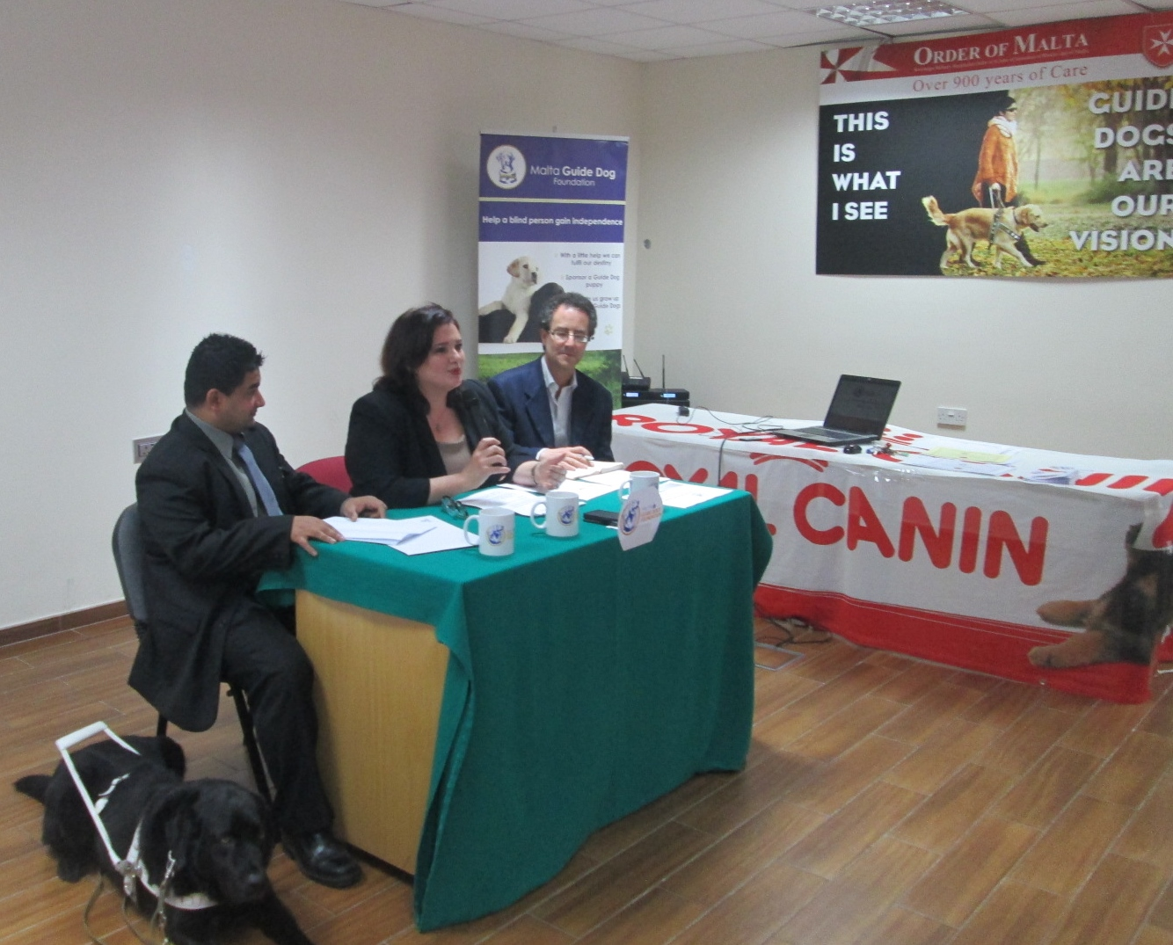
Minister Helena Dalli, flanked by MGDF chairman Leone Sciberras and PRO Malcolm J Naudi during the International Guide Dog Day commemoration

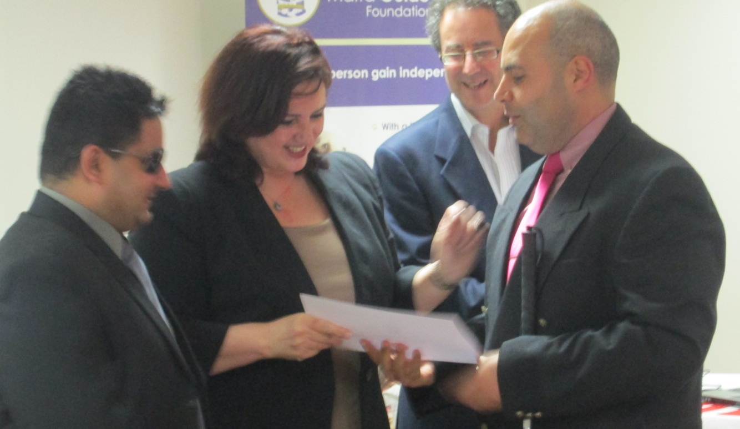
Minister Dalli presenting a certificate following the completion of an Orientation and Mobility course

